Pancreas Cancer

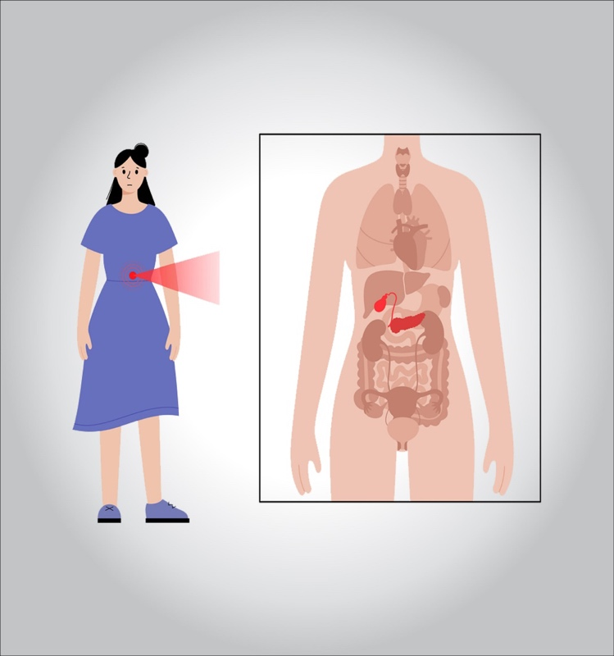

**Pancreatic cancer begins in the tissues of your pancreas — an organ in your abdomen that lies behind the lower part of your stomach. Your pancreas releases enzymes that aid digestion and produces hormones that help manage your blood sugar.**

**Several types of growths can occur in the pancreas, including cancerous and noncancerous tumors. The most common type of cancer that forms in the pancreas begins in the cells that line the ducts that carry digestive enzymes out of the pancreas (pancreatic ductal adenocarcinoma).**

**Pancreatic cancer is seldom detected at its early stages when it’s most curable. This is because it often doesn’t cause symptoms until after it has spread to other organs.**

**Pancreatic cancer treatment options are chosen based on the extent of the cancer. Options may include surgery, chemotherapy, radiation therapy or a combination of these.**

**What are the symptoms?**

**Signs and symptoms of pancreatic cancer often don’t occur until the disease is advanced. They may include:**

* **Abdominal pain that radiates to your back**
* **Loss of appetite or unintended weight loss**
* **Yellowing of your skin and the whites of your eyes (jaundice)**
* **Light-colored stools**
* **Dark-colored urine**
* **Itchy skin**
* **New diagnosis of diabetes or existing diabetes that’s becoming more difficult to control**
* **Blood clots**
* **Fatigue**

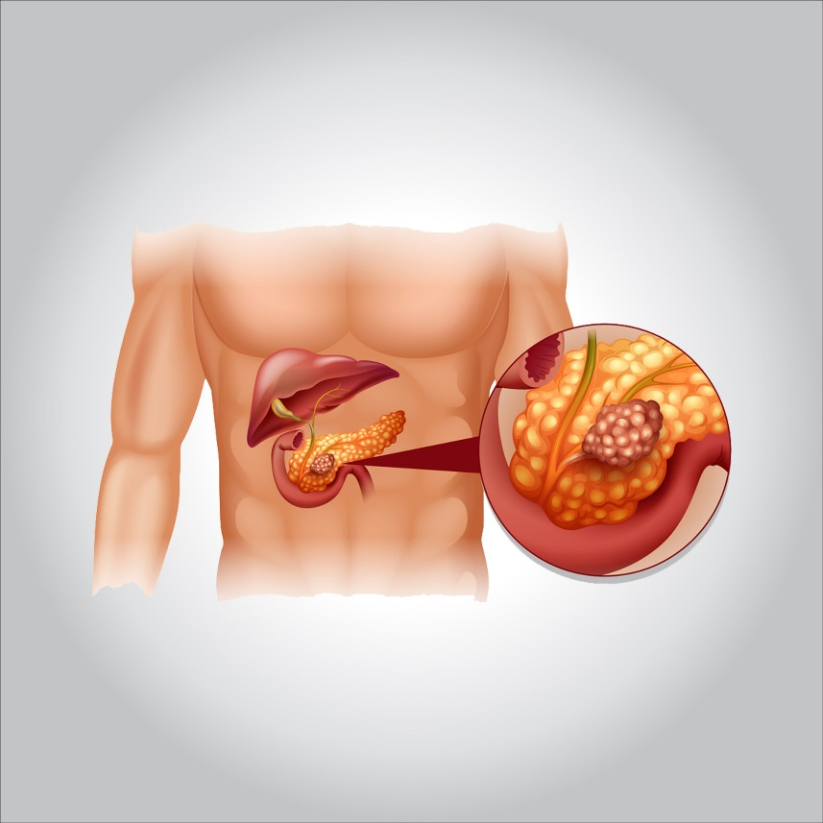

**What are the causes?**

**It’s not clear what causes pancreatic cancer. Doctors have identified some factors that may increase the risk of this type of cancer, including smoking and having certain inherited gene mutations.**

**Understanding your pancreas**

**Your pancreas is about 6 inches (15 centimeters) long and looks something like a pear lying on its side. It releases (secretes) hormones, including insulin, to help your body process sugar in the foods you eat. And it produces digestive juices to help your body digest food and absorb nutrients.**

**How pancreatic cancer forms**

**Pancreatic cancer occurs when cells in your pancreas develop changes (mutations) in their DNA. A cell’s DNA contains the instructions that tell a cell what to do. These mutations tell the cells to grow uncontrollably and to continue living after normal cells would die. These accumulating cells can form a tumor. When left untreated, the pancreatic cancer cells can spread to nearby organs and blood vessels and to distant parts of the body.**

**Most pancreatic cancer begins in the cells that line the ducts of the pancreas. This type of cancer is called pancreatic adenocarcinoma or pancreatic exocrine cancer. Less frequently, cancer can form in the hormone-producing cells or the neuroendocrine cells of the pancreas. These types of cancer are called pancreatic neuroendocrine tumors, islet cell tumors or pancreatic endocrine cancer.**

**Risk factors**

**Factors that may increase your risk of pancreatic cancer include:**

* **Smoking**
* **Diabetes**
* **Chronic inflammation of the pancreas (pancreatitis)**
* **Family history of genetic syndromes that can increase cancer risk, including a BRCA2 gene mutation, Lynch syndrome and familial atypical mole-malignant melanoma (FAMMM) syndrome**
* **Family history of pancreatic cancer**
* **Obesity**
* **Older age, as most people are diagnosed after age 65**

**A large study demonstrated that the combination of smoking, long-standing diabetes and a poor diet increases the risk of pancreatic cancer beyond the risk of any one of these factors alone.**

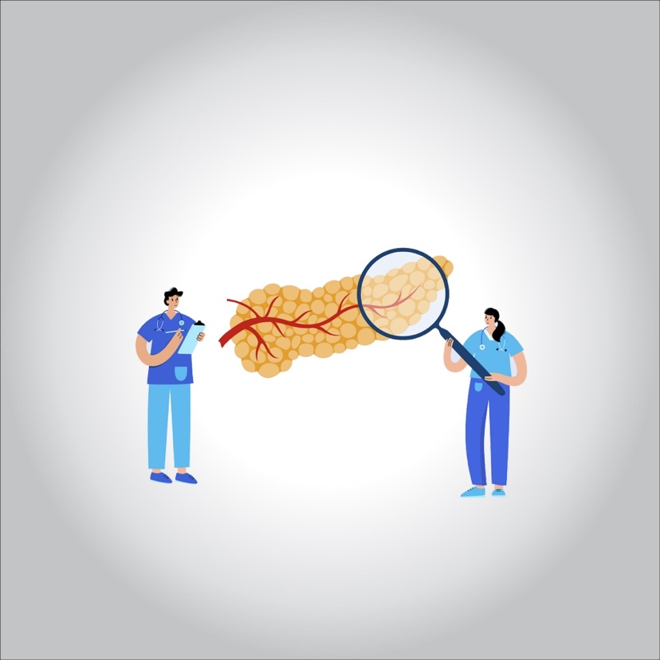

**Complications**

**As pancreatic cancer progresses, it can cause complications such as:**

* **Weight loss. A number of factors may cause weight loss in people with pancreatic cancer. Weight loss might happen as the cancer consumes the body’s energy. Nausea and vomiting caused by cancer treatments or a tumor pressing on your stomach may make it difficult to eat. Or your body may have difficulty processing nutrients from food because your pancreas isn’t making enough digestive juices.**
* **Jaundice. Pancreatic cancer that blocks the liver’s bile duct can cause jaundice. Signs include yellow skin and eyes, dark-colored urine, and pale-colored stools. Jaundice usually occurs without abdominal pain.**

**Your doctor may recommend that a plastic or metal tube (stent) be placed inside the bile duct to hold it open. This is done with the help of a procedure called endoscopic retrograde (ERCP). During ERCP an endoscope is passed down your throat, through your stomach and into the upper part of your small intestine. A dye is then injected into the pancreatic and bile ducts through a small hollow tube (catheter) that’s passed through the endoscope. Finally, images are taken of the ducts.**

* **Pain. A growing tumor may press on nerves in your abdomen, causing pain that can become severe. Pain medications can help you feel more comfortable. Treatments, such as radiation and chemotherapy, might help slow tumor growth and provide some pain relief.**

**In severe cases, your doctor might recommend a procedure to inject alcohol into the nerves that control pain in your abdomen (celiac plexus block). This procedure stops the nerves from sending pain signals to your brain.**

* **Bowel obstruction. Pancreatic cancer that grows into or presses on the first part of the small intestine (duodenum) can block the flow of digested food from your stomach into your intestines.**

**Your doctor may recommend that a tube (stent) be placed in your small intestine to hold it open. In some situations, it might help to have surgery to place a temporary feeding tube or to attach your stomach to a lower point in your intestines that isn’t blocked by cancer.**

**Prevention**

**You may reduce your risk of pancreatic cancer if you:**

* **Stop smoking. If you smoke, try to stop. Talk to your doctor about strategies to help you stop, including support groups, medications and nicotine replacement therapy. If you don’t smoke, don’t start.**
* **Maintain a healthy weight. If you are at a healthy weight, work to maintain it. If you need to lose weight, aim for a slow, steady weight loss — 1 to 2 pounds (0.5 to 1 kilogram) a week. Combine daily exercise with a diet rich in vegetables, fruit and whole grains with smaller portions to help you lose weight.**
* **Choose a healthy diet. A diet full of colorful fruits and vegetables and whole grains may help reduce your risk of cancer.**

**Consider meeting with a genetic counselor if you have a family history of pancreatic cancer. He or she can review your family health history with you and determine whether you might benefit from a genetic test to understand your risk of pancreatic cancer or other cancers.**

**What is the treatment?**

**Treatment for pancreatic cancer depends on the stage and location of the cancer as well as on your overall health and personal preferences. For most people, the first goal of pancreatic cancer treatment is to eliminate the cancer, when possible. When that isn’t an option, the focus may be on improving your quality of life and limiting the cancer from growing or causing more harm.**

**Treatment may include surgery, radiation, chemotherapy or a combination of these. When pancreatic cancer is advanced and these treatments aren’t likely to offer a benefit, your doctor will focus on symptom relief (palliative care) to keep you as comfortable as possible for as long as possible.**

**Surgery**

**Operations used in people with pancreatic cancer include:**

* **Surgery for tumors in the pancreatic head. If your cancer is located in the head of the pancreas, you may consider an operation called a Whipple procedure**

**The Whipple procedure is a technically difficult operation to remove the head of the pancreas, the first part of the small intestine (duodenum), the gallbladder, part of the bile duct and nearby lymph nodes. In some situations, part of the stomach and colon may be removed as well. Your surgeon reconnects the remaining parts of your pancreas, stomach and intestines to allow you to digest food.**

* **Surgery for tumors in the pancreatic body and tail. Surgery to remove the left side (body and tail) of the pancreas is called distal pancreatectomy. Your surgeon may also need to remove your spleen.**
* **Surgery to remove the entire pancreas. In some people, the entire pancreas may need to be removed. This is called total pancreatectomy. You can live relatively normally without a pancreas but do need lifelong insulin and enzyme replacement.**
* **Surgery for tumors affecting nearby blood vessels. Many people with advanced pancreatic cancer aren’t considered eligible for the Whipple procedure or other pancreatic surgeries if their tumors involve nearby blood vessels. At highly specialized and experienced medical centers, surgeons may offer pancreatic surgery operations that include removing and reconstructing affected blood vessels.**

**Each of these surgeries carries the risk of bleeding and infection. After surgery some people experience nausea and vomiting if the stomach has difficulty emptying (delayed gastric emptying). Expect a long recovery after any of these procedures. You’ll spend several days in the hospital and then recover for several weeks at home.**

**Extensive research shows pancreatic cancer surgery tends to cause fewer complications when done by highly experienced surgeons at centers that do many of these operations. Don’t hesitate to ask about your surgeon’s and hospital’s experience with pancreatic cancer surgery. If you have any doubts, get a second opinion.**

**Chemotherapy**

**Chemotherapy uses drugs to help kill cancer cells. These drugs can be injected into a vein or taken orally. You may receive one chemotherapy drug or a combination of them.**

**Chemotherapy can also be combined with radiation therapy (chemo radiation). Chemo radiation is typically used to treat cancer that hasn’t spread beyond the pancreas to other organs. At specialized medical centers, this combination may be used before surgery to help shrink the tumor. Sometimes it is used after surgery to reduce the risk that pancreatic cancer may recur.**

**In people with advanced pancreatic cancer and cancer that has spread to other parts of the body, chemotherapy may be used to control cancer growth, relieve symptoms and prolong survival.**

**Radiation therapy**

**Radiation therapy uses high-energy beams, such as those made from X-rays and protons, to destroy cancer cells. You may receive radiation treatments before or after cancer surgery, often in combination with chemotherapy. Or your doctor may recommend a combination of radiation and chemotherapy treatments when your cancer can’t be treated surgically.**

**Radiation therapy usually comes from a machine that moves around you, directing radiation to specific points on your body (external beam radiation). In specialized medical centers, radiation therapy may be delivered during surgery (intraoperative radiation).**

**Traditional radiation therapy uses X-rays to treat cancer, but a newer form of radiation using protons is available at some medical centers. In certain situations, proton therapy can be used to treat pancreatic cancer and it may offer fewer side effects compared with standard radiation therapy.**

**Clinical trials**

**Clinical trials are studies to test new treatments, such as systemic therapy, and new approaches to surgery or radiation therapy. If the treatment being studied proves to be safer and more effective than current treatments, it can become the new standard of care.**

**Clinical trials for pancreatic cancer might give you a chance to try new targeted therapy, chemotherapy drugs, immunotherapy treatments or vaccines.**

**Clinical trials can’t guarantee a cure, and they might have serious or unexpected side effects. On the other hand, cancer clinical trials are closely monitored to ensure they’re conducted as safely as possible. And they offer access to treatments that wouldn’t otherwise be available to you.**

**Talk to your doctor about what clinical trials might be appropriate for you.**

**Supportive (palliative) care**

**Palliative care is specialized medical care that focuses on providing relief from pain and other symptoms of a serious illness. Palliative care is not the same as hospice care or end-of-life care. Palliative care is provided by teams of doctors, nurses, social workers and other specially trained professionals. These teams aim to improve the quality of life for people with cancer and their families.**

**Palliative care specialists work with you, your family and your other doctors to provide an extra layer of support that complements your ongoing medical care. It’s often used while undergoing aggressive treatments, such as surgery, chemotherapy and radiation therapy.**

**When palliative care is used along with other appropriate treatments — even soon after the diagnosis — people with cancer may feel better and live longer.**